# ABC’s Inventory Management System

## Test Script

|  |  |  |  |  |  |
| --- | --- | --- | --- | --- | --- |
| **Test Name** | | Test Search Product Using Unknown Product Code (Test Case SPT002) | | | |
| **Use Case Tested** | | Search Product | | | |
| **Test Description** | | This test tests if the system can retrieve product item details and contents in each location using a random product code. This random product code value can be of any format i.e. it does not have to follow the product code format that has been prescribed by the business. | | | |
| **Pre-Conditions** | | Meta data must exist, product and product details like product code, product item code, location ID and so on must exist even though it may or may not be accessed which is based on the product code that will be entered. | | | |
| **Post-Conditions** | | If product code matches to the product code entry in the database, the matching product on each location is displayed through product code i.e. matching product is displayed through which product items belonging to the product is viewed. However, if product code does not match to any of the product code entry in the database, an appropriate message is displayed. | | | |
| **Notes** | | This test allows users to view product items using a product code.  This test shows appropriate messages are displayed for every user action (Addressing the usability requirement of the system). | | | |
| **Result (Pass/Fail/Warning/ Incomplete)** | | Pass | | | |
|  | **Test Step** | | **Expected Test Results** | **P** | **F** |
| 1. | Open the ABCInventoryClient.exe file | | ABCInventoryClient system launches. | P |  |
| 2. | Type in the product code in the product code field. | | System waits for the user to hit enter or click on the ‘Search’ button. | P |  |
| 3. | Hit enter or click on the ‘Search’ button. | | If product code matches with the product code entry in the database, product with matching product code is displayed with all other product details like total quantity, price, name, etc. along with the location details separated according to the location. | P |  |
|  |  | | If product code does not match with the product code entry in the database, an appropriate message is displayed notifying users that the product does not exist. | P |  |
| 4. | If Product Code matches click on details to check product item details in the desired location. | | Product Items’ details belonging to the product in the location that was selected is displayed. | P |  |

|  |  |  |  |
| --- | --- | --- | --- |
| **Test Data Table** | | | |
|  | **1** | **2** | **3** |
| **Product Code** | S2 | A321 | S5 |
| **Location ID** | STR1 | - | - |
| **Location Name** | Oxford Store | - | - |

# Result Screenshots

The screenshots of the result on each test step for each data set are given below:

## Data Set 1

**Step 1**

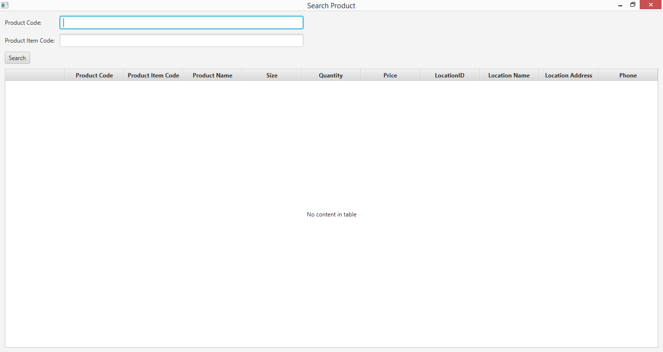

**Step 2**

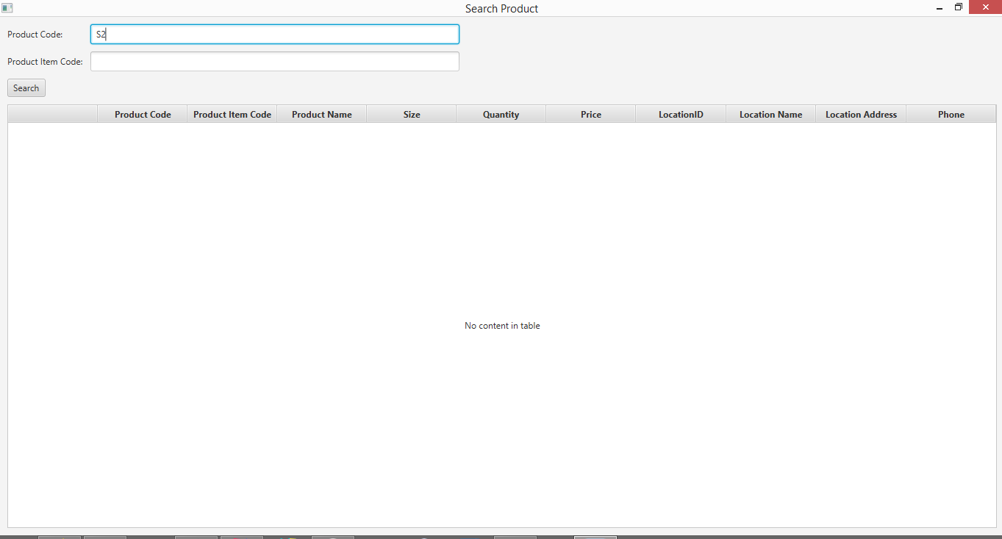

**Step 3**

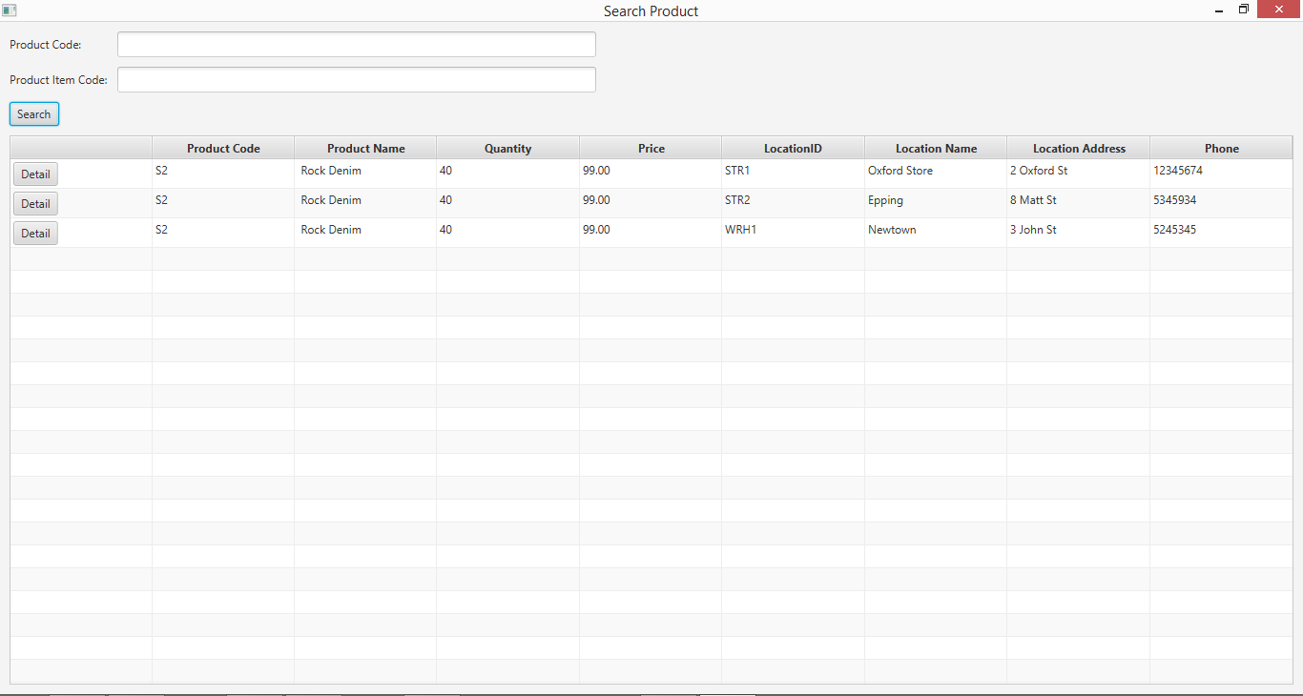

**Step 4**

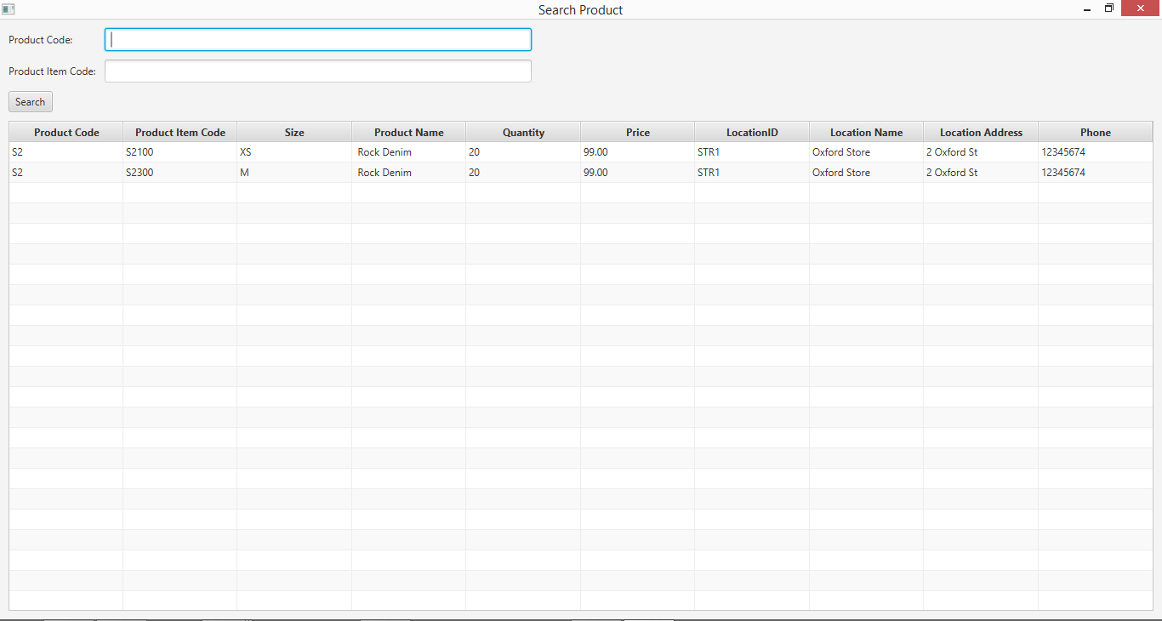

## Data Set 2

**Step 1**



**Step 2**

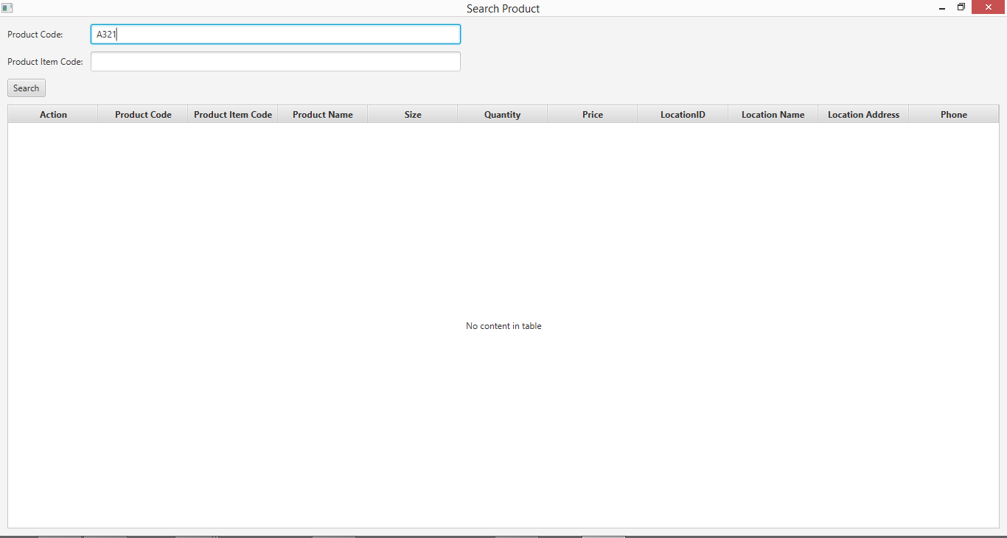

**Step 3**

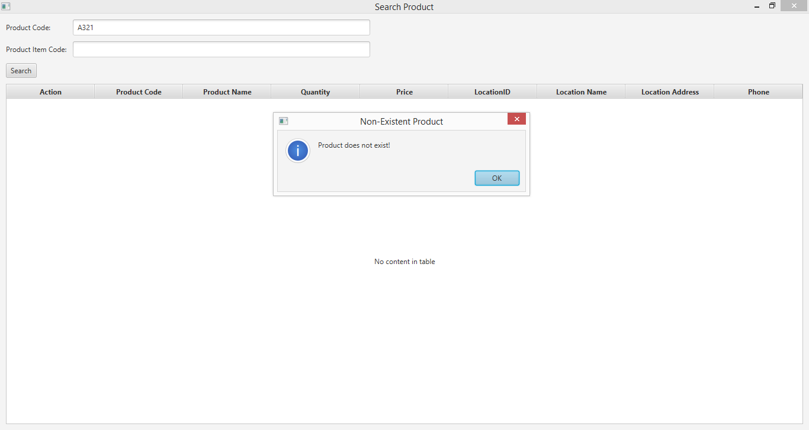

## Data Set 3

**Step 1**



**Step 2**

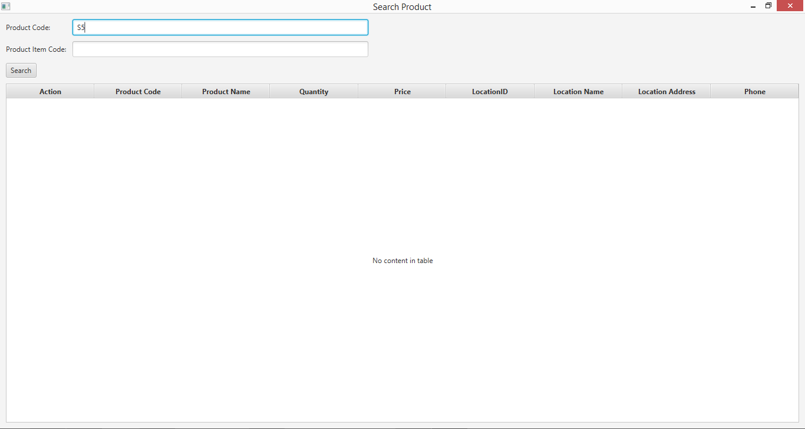

**Step 3**

